Suggested Work for Monday 8th-Friday 12th June
Good morning everyone,
We are fast approaching the end of the school year and I know you have all been working very hard at home for a long time now. This week, Ms. Byrne and I have included several fun activities along with a little bit of maths and English book work. I hope you will enjoy trying out some of the nice ideas you will find below. A big Happy Birthday to Alanna for this Thursday 11th June, when she will turn 8. Have a great day Alanna!
This week I would like you to send me photos of your minibeast scavenger hunt or any photos of the active work included in this week’s homework list. Another piece of work you could send me is your gratitude list, your decorated stones/shells or your Friday Spelling Test. My email address is mss1@realtnamaradonacarney.ie which parents can also use for any queries they may have about their child’s school work.
Please remember that the lists of weekly work posted here are just suggestions of the schoolwork that the girls could being doing at home. It is not expected that every child will be able to complete all of the work listed below.
Monday 8th June
English: Spellings- ‘ur’ sound. Your daughter does not have the spelling list for this week in her spelling notebook, so please have her copy the list below into this notebook. Can you write a list of some other words with this sound? Learn spellings 1-3 from the list today.
‘ur’
not
sum
next
turn
nurse
turkey
purple
love
cover
hamburger
​Geraldine the Giraffe learns the ‘ur’ sound too!
https://www.youtube.com/watch?v=Q49YSWKPyVo&t=8s
Play some games on the ‘Phonicsplay’ website to practise the ‘ur’ sound and other digraphs.
https://new.phonicsplay.co.uk/

You can also play this ‘ur’ Roll & Read game.
https://www.twinkl.ie/resource/t-l-4046-phase-3-ur-phoneme-roll-and-read-mat
Handwriting- 'Go with the Flow' page 60. Learn to join ‘ff’ and ‘rr’.
You can watch ‘Flowie’ the dog showing you how to do all the letter joins here. http://data.cjfallon.ie/resources/gwtf-handwriting/index.html#!/book-sections/2/section-activities/1
Maths: Master Your Maths pg 62 Monday section. Please write number sentences (sums) for word problems 11&12.
Tables: Today and tomorrow you are going to revise the 10+ tables. Please revise the first 7 number facts today.
10+ 0 = 10
10+ 1 = 11
10 + 2 = 12
10 + 3 = 13
10 + 4 = 14
10 + 5 = 15
10 + 6 = 16
10 + 7 = 17
10+ 8 = 18
10 + 9 = 19
10 + 10 = 20
10 + 11 = 21
10 + 12 = 22
S.E.S.E Minibeasts
Today you are going to learn about minibeasts! If you watched the RTE School Hub programme last week you might have seen one of the presenters teaching a lesson about them. We also read a report about minibeasts when we were still in school. Can you tell your parents or siblings what you already know about minibeasts?
Minibeasts are small animals. All minibeasts have one thing in common: they do not have a backbone. Minibeasts are all around us, they are the largest group of animals on earth. Go to pg 22 of your Starlight book to re-read some more interesting facts about minibeasts!
Take a look at these minibeasts. Do you recognise most of them?
https://www.twinkl.ie/resource/t2-s-1165-insects-photo-powerpoint
Read through these cards to find out more information about different minibeasts.
https://content.twinkl.co.uk/resource/dc/89/t2-s-1169-insect-information-cards-.pdf?__token__=exp=1591371072~acl=%2Fresource%2Fdc%2F89%2Ft2-s-1169-insect-information-cards-.pdf%2A~hmac=b77670412115bf663580a1b601e18c38ec0939a7009a38c552bf0f46483022d3
Watch this video to find out more about minibeasts.
https://www.youtube.com/watch?v=rKQfJFAHW8Q
Use the clues to guess the minibeasts!
https://www.twinkl.ie/resource/t-t-5145-minibeasts-what-am-i-interactive-powerpoint-game
Activity:
Go on a minibeast scavenger hunt in your garden, local park, or any green area that you have access to and see how many different types of minibeasts you can find and tick off the list!
Have fun
https://content.twinkl.co.uk/resource/0f/ff/t-t-019-eyfs-minibeast-hunt-checklist-_ver_2.pdf?__token__=exp=1591370654~acl=%2Fresource%2F0f%2Fff%2Ft-t-019-eyfs-minibeast-hunt-checklist-_ver_2.pdf%2A~hmac=af42ae6053396b44fa9f833f308f9b64342f7b8d468a0c97d3756c26f2e6581e
There are lots more ‘minibeast’ activities and resources available on twinkl.

Tuesday 9th June
English: Spellings- ‘ur’ Learn spellings 4-6 from list.
Story: Mad About Minibeasts https://youtu.be/3rDQN8I7RkY
Use your imagination and see if you can make up a different ending to the story.
Maths: Master your Maths page 62, Tuesday section. Please write number sentences (sums) for word problems 11&12.
Tables: Please revise the last 6 number facts from the 10+ tables today.
10+ 0 = 10
10+ 1 = 11
10 + 2 = 12
10 + 3 = 13
10 + 4 = 14
10 + 5 = 15
10 + 6 = 16
10 + 7 = 17
10+ 8 = 18
10 + 9 = 19
10 + 10 = 20
10 + 11 = 21
10 + 12 = 22

P.E Download this link and follow the ‘What’s Your Name’ workout.
file:///C:/Users/Teacher/Desktop/Covid%2019%20Photo%20album/WHATS%20YOUR%20NAME%20WORKOUT.webp

Wednesday 10th June
English: Spellings- ‘ur’ Learn spellings 7-9 from list.
Handwriting- 'Go with the Flow' page 61. Learn to join ‘qu’ and ‘bb’
Maths: Master your Maths page 63, Wednesday section. Please write number sentences (sums) for word problems 11&12.
Tables: Today and tomorrow you are going to revise the 11+ tables. Please revise the first 7 number facts today.
11+ 0 = 11
11+ 1 = 12
11+ 2 = 13
11+ 3 = 14
11+ 4 = 15
11+ 5 = 16
11+ 6 = 17
11+ 7 = 18
11 + 8 = 19
11 + 9 = 20
11 + 10 = 21
11 + 11 = 22
11 + 12 = 23
P.E. & Music Get moving with some of these fun action songs from ‘The Learning Station’. https://www.youtube.com/playlist?list=PL17F1F193E453DB97

S.P.H.E There are many things in our lives that we should be grateful for; our family and friends, our cosy homes, our school, sunny days, nature etc. Sometimes thinking about these things or even writing them down makes us appreciate them a little more every day. Follow the list below and go on a ‘Gratitude Scavenger Hunt’. You could also write a list of all of the things that you are grateful for today and decorate it nicely!
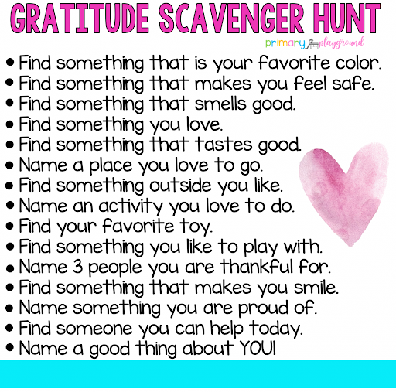

Thursday 11th June
English: Story ‘The Cautious Caterpillar’. Read and enjoy this story! https://www.twinkl.ie/resources/ks1-twinkl-originals-key-stage-1/twinkl-educational-publishing-fiction-story-books-story-primary-resources-english-key-stage-1/the-cautious-caterpillar-fiction-ks1-twinkl-originals
Spellings- ‘ur’ learn spelling 10 and revise all.
Maths: Master your Maths page 63, Thursday section. Please write number sentences (sums) for the word problems 11&12.
Tables: Please revise the last 6 number facts from the 11+ tables today.
11+ 0 = 11
11+ 1 = 12
11+ 2 = 13
11+ 3 = 14
11+ 4 = 15
11+ 5 = 16
11+ 6 = 17
11+ 7 = 18
11 + 8 = 19
11 + 9 = 20
11 + 10 = 21
11 + 11 = 22
11 + 12 = 23
Art /SPHE: Stay connected: Why not brighten up another person’s day this week by decorating stones or shells (like the examples below) and giving them to someone you know, or dropping them in different places on your next walk for others to find. I’m sure finding one would put a big smile on somebody’s face!

Friday 12th June
English: Spellings- Ask a parent to test you on the ‘ur’ spelling list by calling out these sentences for you to write down. The 10 words from the list are underlined.
1. The nurse has a purple watch.
2. Did you do the next sum?
3. Do not turn over the cover of the book.
4. I love to eat hamburgers.
5. Did you see the turkey on the farm?
Handwriting- 'Go with the Flow' page 62. Learn to join ‘mm’ and ‘dd’.
Read this poem aloud and add your own actions
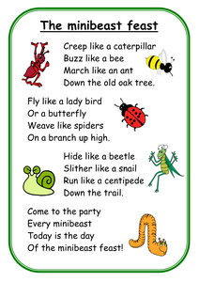
Maths: Speed test on +10 and +11 tables. (90 seconds)

S.P.H.E: Go on a colour walk/cycle. It is important to stay active for our bodies and minds. Get outdoors, take in some fresh air and appreciate the beauty of nature all around you!
https://drive.google.com/file/d/0B-cVjZBMBNNXTDVVbUNtLWV4UGc/view
RTE Home School Hub-This programme is aimed at children from 1st to 6th class and is currently on every weekday from 11am to 12pm on RTE2. It is presented by three primary school teachers and covers a wide range of subjects across the curriculum. (This programme is also available to stream on RTE player). Children can also access lots of engaging, educational content online, which is available on www.rte.ie/learn​
This week’s ‘School Hub’ timetable for 1st/2nd class this week is as follows:
Monday- English: Writing Skills
Tuesday- Drama: Body, Eyes and Props
Wednesday- Science: Parachutes
Thursday- Gaeilge: Cluichí sa Bhaile (Games at Home)
Friday- Geography: The Moon

